**6 Things You Should Know About Electronics Recycling**

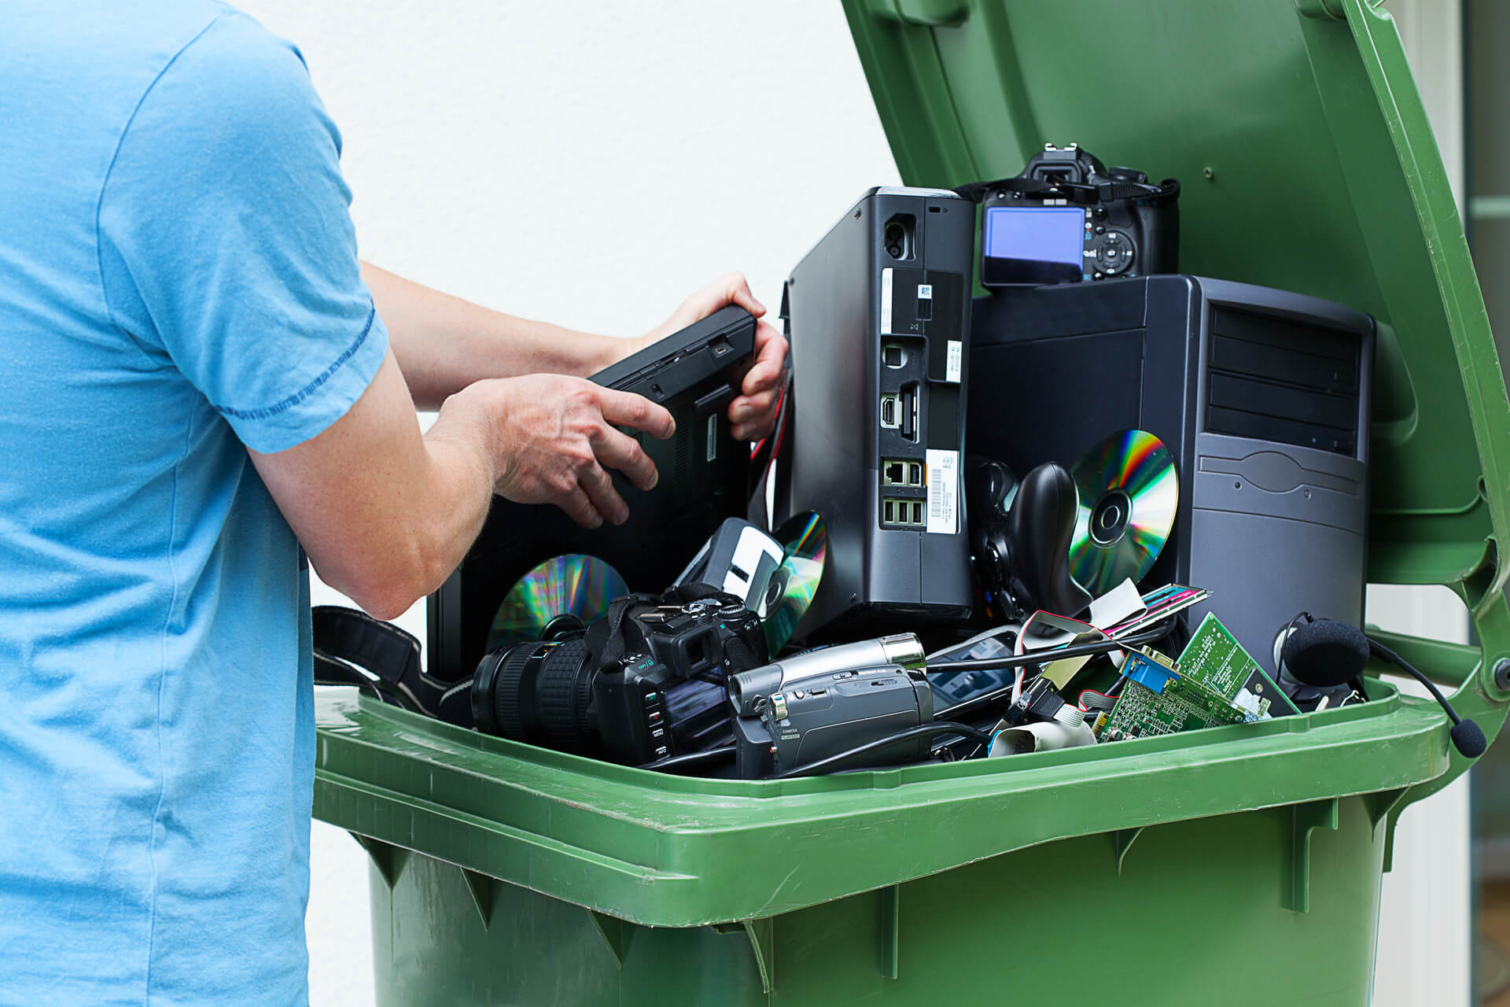

You should know by now that recycling your devices is a far better option than throwing it away at the garbage. We could talk about the dangers of e-waste and how improper disposal methods are wreaking havoc on the ecosystem all day.

Other statistics about electronics recycling, on the other hand, are a little less well-known. Here are six of our favourite facts that can persuade you to recycle your old gadgets at a facility like Recycle Pro.

1. **Materials from your computer can be used for a variety of purposes.**

Although you may consider the plastics and metals in your old laptops to be worthless once your technology has passed away, we consider them important raw resources.

When you recycle electronics, you can easily turn your old materials into:

* Cell Phones
* Jewellery
* Metal Plates
* Automotive Parts, etc.

1. **There are no federal laws governing computer recycling**

Did you realise that at the federal level, there is no protection against e-waste? State officials must decide how or if their state will battle e-waste through effective recycling systems.

When it comes time to get rid of televisions and laptops, Texas lawmakers mandate that consumers be offered electronic recycling options.

1. **Electronics Must Be Recycled by a Professional**

A [licenced electronic recycling](https://www.recyclepro.co.uk/) professional should handle the job to ensure that your computers and electrical equipment are properly broken down and do not add to e-waste.

With each recycling operation we conduct, we are accredited and ensure ethical environmental procedures.

1. **Wipe the Data on Your Computer**

The last thing you want is for your old computer to end out on the curb or in a dump, only for a criminal to gain access to it and exploit it to their benefit and your detriment.

You can't protect yourself from malicious hackers by crushing your old equipment. Only asset disposition services, such as those offered by Recycle Pro, can guarantee that your data is entirely deleted, shredded, and untraceable.

1. **There are two types of electronic recycling standards**

A corporation cannot just declare itself to be an electronics recycling company. They must first go through one of two national electronics recycling criteria.

The E-Stewards and R2 certificates indicate that a recycling organisation is well-equipped to recycle your electronics in an environmentally responsible manner.

1. **Everybody has unused technology that they can get rid of**

No matter who you are, your house or business is likely to have a closet dedicated to keeping electronics that are either defective or that you no longer require.

It is normal to keep valuable equipment after it has served its usefulness. However, room is limited, and a recycling firm like Recycle Pro is the ideal place to responsibly reduce your electronics burden.

**With Recycle Pro, you can easily recycle your electronics.**

If you manage a business and know you have a lot of electronics to get rid of, the professionals at Recycle Pro can assist you in taking the proper environmental steps. We are Birmingham's leading electronics recycling facility, and we can assist you in conserving the environment while safely disposing of your technical assets.

To learn more about our electronic pick-up services or how to drop off your gadgets at our location, [contact us now](https://www.recyclepro.co.uk/).